The Enochian
Banishing Ritual of The Hexagram

Step 1:
Face your Altar. Pick up your Wand with your right hand. Stand with your feet together, your left arm down at your side and your right arm across your body holding your Wand upright in front of you.
Step 2:
Turn to the East and say: IVITDT (Ee-veh-ee-teh-deh-teh) while tracing a Yellow Banishing Hexagram of Air before you. (Vibrate one letter of this six-lettered formula as you trace a corresponding side of the Hexagram.):
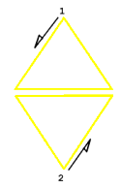
Then say:
"Behold the Burning Flames of Truth the consume sorrow, sin and death."
Step 3:
Turn to the South and say: ZTZTZT (Zeh-teh-zeh-teh-zeh-teh) while tracing the Red Banishing Hexagram of Fire before you. (Vibrate one letter of this six-lettered formula as you trace a corresponding side of the Hexagram.)
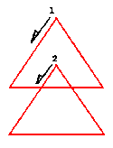
Then say:
"Behold, the Way of Love is to Sacrifice All into the Cup."
Step 4:
Turn to the West and say: IVITDT (Ee-veh-ee-teh-deh-teh) while tracing the Blue Banishing Hexagram of Water before you. (Vibrate one letter of this six-lettered formula as you trace a corresponding side of the Hexagram.)
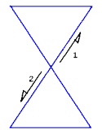
Then say:
"Behold, the Burning Flames of Truth that consume sorrow, sin and death."
Step 5:
Turn to the North and say: ZTZTZT (Zeh-teh-zeh-teh-zeh-teh) while tracing the Black Banishing Hexagram of Earth before you. (Vibrate one letter of this six-lettered formula as you trace a corresponding side of the Hexagram.).
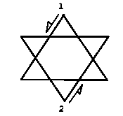
Then say:
"Behold, the Way of Love is to
Sacrifice All into the Cup."
Step 6:
While still facing North, extend your arms outward to your sides to form a cross. The Wand should be pointing straight up in your right hand. Then say:
Before Me MOR-DIAL-HKTGA
(Moh-reh Dee-ah-leh Heh-keh-teh-gah)
Behind Me OIP-TEAA-PDOKE
(Oh-ee-peh The-ah-ah Peh-doh-keh)
On My Right ORO-IBAH-AOZPI
(Oh-roh Ee-bah-heh Ah-oh-zeh-pee)
On My Left MPH-ARSL-GAIOL
(Meh-peh-heh Ah-reh-seh-leh Gah-ee-oh-leh)
"Above me and below me,
My Magickal Universe,
And behold, I alone
in the midst."
Step 7:
While still facing the North, replace the Wand on the Altar. Relax your arms and hold them down to your sides. Stand quietly for several minutes with your eyes closed and feel the energy that you have just put into action.

