Invoking The Seniors of the Watchtower

Each of the twenty-four Seniors of the Watchtowers can be invoked by The Magus. If performed properly, during your invocations, a Senior will actually enter into your body. You will temporarily become the Senior. You will act as he acts, and you will assume his characteristics and powers for yourself. The following is a general outline for such an invocation:
STEP 1. Face the appropriate Watchtower:
a. Earth in the North
b. Water in the West
c. Air in the East
d. Fire in the South
STEP 2. Trace the appropriate invoking hexagram.
STEP 3. Vibrate the appropriate Names of Power:
a. Great Holy Name
b. King
c. Senior
STEP 4. Enter your Body of Light.
STEP 5. Assume the god-form of the Senior.
STEP 6. Recite the appropriate invocation.
STEP 7. Assume the characteristics of the Senior.
STEP 8. Enter the appropriate Watchtower.
STEP 9. Perform your desired magical operation.
STEP 10. Trace the appropriate banishing hexagram.
STEP 11. Release the god-form.
STEP 12. Return to your physical body.

EXAMPLES OF INVOKING SENIORS
EXAMPLE 1. INVOCATION OF LAIDROM
STEP 1. Face North.
STEP 2. Create a protective circle.
STEP 3. Enter your Body of Light.
STEP 4. Trace the invoking hexagram for Mars. | 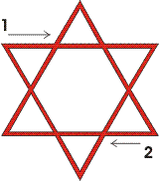
STEP 5. Vibrate the names:
MORDIALHKTGA (Moh-ar Dee-ah-leh Heh-keh-teh-gah)
IKZHIKAL (Ee-keh-zoad-hee-kal)
LAIDROM (El-ahee-dar-oh-em)
STEP 6. Assume the god-form of LAIDROM. Let your Body of Light take on the appearance of this Senior. Although all Seniors are male, LAIDROM is rather feminine. His body is well-proportioned and beautiful to look upon. He is graceful and rather delicate with a slightly protruding stomach. He has a small pair of wings. He wears a transparent robe of light green. In his right hand he carries a Pantacle in the shape and color of a sunflower.
STEP 7. Recite an invocation:  O LAIDROM, Senior of Earth,  Come to me and assist me.  Help me to know  The secrets of truth.  Grant me your great boon  Of Occult Knowledge.  Assist me in my meditation  And calm my restless mind. | 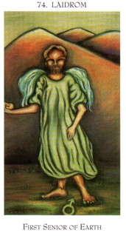
STEP 8. Assume the character of LAIDROM. This Senior bestows occult knowledge. He has the energy of Mars and yet is passive like the mind in meditation. His presence calms the animalistic impulses and desires.
STEP 9. Enter the Watchtower of Earth in the form of LAIDROM and perform magical operations according to your will.
STEP 10. Trace the banishing hexagram of Mars. | 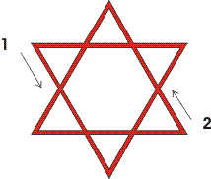
STEP 11. Return to your own form. Conduct any additional banishing that you feel necessary such as the Enochian Hexagram Ritual. Return to your physical body.

EXAMPLE 2. INVOCATION OF LSRAHPM
STEP 1. Face West.
STEP 2. Create a protective circle.
STEP 3. Enter your Body of Light.
STEP 4. Trace the invoking hexagram for Mars.
STEP 5. Vibrate the names:
MPHARSLGAIOL (Em-peh-heh Ar-ess-el Gah-ee-oh-leh)
RAAGIOSL (Rah-ah-gee-oh-sel)
LSRAHPM (Less-rah-pem)
STEP 6. Assume the god-form of LSRAHPM. Let your Body of Light take on the appearance of this Senior. Although all Seniors are male, LSRAHPM is rather feminine. His body is well-proportioned and graceful but the lower half shimmers as though indistinct. He has a small pair of wings. He wears an orange robe. In his right hand he carries an oak spear and in his left hand is a lighting bolt. His overall impression is one of fierce determination.
STEP 7. Recite an invocation:  O LSRAHPM, Senior of Water,  Come to me and assist me.  Help me to slay  All that opposes my progress.  Grant me your great boon  Of Occult Powers.  Assist me in my Magical Will  And tear asunder my enemies. | 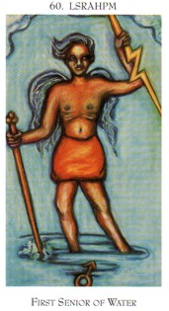
STEP 8. Assume the character of LSRAHPM. This Senior bestows occult powers. He has the energy of Mars and his spear and lighting bolt can destroy the enemies of truth. His presence stirs the desire to control one's life and to attain all manner of magical powers (Siddhas).
STEP 9. Enter the Watchtower of Water in the form of LSRAHPM and perform magical operations according to your will.
STEP 10. Trace the banishing hexagram of Mars.
STEP 11. Return to your own form. Conduct any additional banishing that you feel necessary such as the Enochian Hexagram Ritual. Return to your physical body.

EXAMPLE 3. INVOCATION OF AAOZAIF
STEP 1. Face East.
STEP 2. Create a protective circle.
STEP 3. Enter your Body of Light.
STEP 4. Trace the invoking hexagram for Jupiter. | 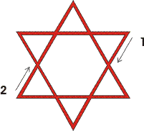
STEP 5. Vibrate the names:
OROIBAHAOZPI (Oh-roh Ee-beh Ah-oh-zoad-pee)
BATAIVAH (Bah-tah-ee-vah-heh)
AAOZAIF (Ah-ah-oh-zoadah-ee-feh)
STEP 6. Assume the god-form of AAOZAIF. Let your Body of Light take on the appearance of this Senior. This Senior is thin but definitely masculine. He has a pair of very large wings. He wears a crimson robe. In his right hand he carries a dagger and his left hand is raised with palm outward in a gesture of granting boons. His overall impression is one who is seeking something.
STEP 7. Recite an invocation:  O AAOZAIF, Senior of Air,  Come to me and assist me.  Help me to find  The knowledge that becomes wisdom.  Grant me your great boon  Of instant mobility.  Help me to tread the path  Whereon I might find myself. | 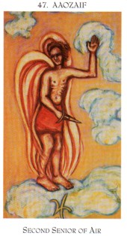
STEP 8. Assume the character of AAOZAIF. This Senior bestows the ability to instantly appear anywhere in space. He has the generosity of Jupiter and he is always moving about in an endless search for knowledge. His presence stirs the desire to find oneself and to learn what life is all about.
STEP 9. Enter the Watchtower of Air in the form of AAOZAIF and perform magical operations according to your will.
STEP 10. Trace the banishing hexagram of Jupiter. | 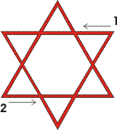

STEP 11. Return to your own form. Conduct any additional banishing that you feel necessary such as the Enochian Hexagram Ritual. Return to your physical body.
EXAMPLE 4. INVOCATION OF ARINNAP
STEP 1. Face South.
STEP 2. Create a protective circle.
STEP 3. Enter your Body of Light.
STEP 4. Trace the invoking hexagram for Saturn. | 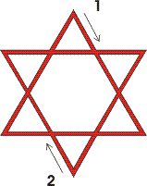
STEP 5. Vibrate the names:
OIPTEAAPDOKE (Oh-ee-peh Teh-ah-ah Peh-doh-keh)
EDLPRNAA (Eh-del-par-nah-ah)
ARINNAP (Ah-ree-neh-nah-peh)
STEP 6. Assume the god-form of ARINNAP. Let your Body of Light take on the appearance of this Senior. This Senior is very muscular, with dark hair and eyes. He has a pair of very large wings. He wears a pale yellow robe. In his right hand he carries a short sword with a topaz studded hilt. In his left hand is a sprig of peppermint. His overall impression is one who is protective.
STEP 7. Recite an invocation:  O ARINNAP, Senior of Fire,  Come to me and assist me.  Help me to find security  And protection from my enemies.  Grant me your great boon  Of divination.  Help me to see right action  And keep the foe from my path. | 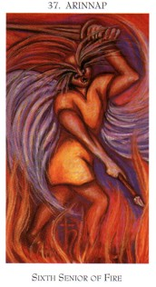
STEP 8. Assume the character of ARINNAP. This Senior bestows the ability to perform divination. He has the self-preservation of Saturn and he is a powerful protector. His presence eliminates fear.
STEP 9. Enter the Watchtower of Fire in the form of ARINNAP and perform magical operations according to your will.
STEP 10. Trace the banishing hexagram of Saturn. | 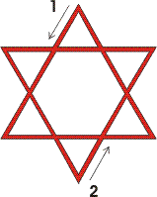
STEP 11. Return to your own form. Conduct any additional banishing that you feel necessary such as the Enochian Hexagram Ritual given in Section 2. Return to your physical body.

